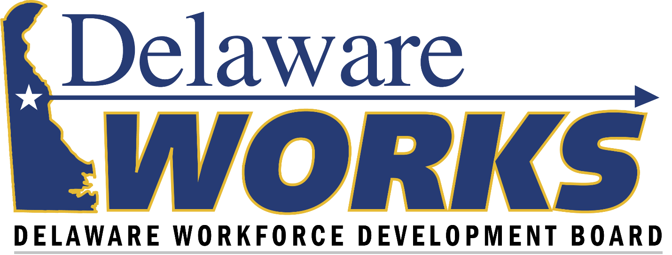

**Proposed Eligible Training Provider List (ETPL) & Individual Training Account (ITA) Policy and Procedures**

**4425 North Market Street**

**Wilmington, DE 19802**

**Email:** [**dwdb_etpl@delaware.gov**](mailto:dwdb_etpl@delaware.gov)

OVERVIEW 3

General Guidance: 4

Demand Occupation List: 4

Performance Measures: 4

Performance Reporting 5

Delaware JobLink 5

Memorandum of Understating (MOU) 5

How Funds are Distributed 6

Enforcement 6

Non-compliance suspension 7

New Provider Application Process: 8

New Provider Eligibility Process 8

New Programs 10

Renewals 11

Provider Forum: 11

Renewal Application Process for Training Providers: 11

ETPL Renewal Staff Process 12

Appendix A: Step by Step Visual: 15

Entering a New Provider in DJL 15

Entering a New Program to DJL 18

Appendix B: MOU 19

Appendix C: Initial Application Policy 24

Appendix D: Subsequent Renewal Policy 27

Appendix E: Adding Registered Apprenticeship (RA) Program Sponsors to the Eligible Training Provider List (ETPL) Policy 30

Appendix F: Monitoring Policy 32

Appendix G: Appeals Process Policy 39

Appendix H: Participant Complaint Procedure 41

Appendix I: Program Removal Form 43

# OVERVIEW

This Eligible Training Provider List (ETPL) and Individual Training Account (ITA) Provider policy manual outlines the Delaware Workforce Development Board’s (DWDB) approach to managing its responsibility under the Workforce Innovational and Opportunity Act (WIOA). This manual provides specific guidance on the development, management, policies, and enforcement.

Delaware’s ETPL is a list of training programs that participants in the WIOA Adult and WIOA Dislocated Worker Program use to select training that qualifies for WIOA-funded tuition assistance. This list is also used by partners, such as Division of Employment and Training, Division of Vocational Rehabilitation, and others, for training opportunities for their clients.

Organizations offering training that would like to have their programs included on the ETPL must apply through Delaware JobLinks (DJL). Once approved, individuals seeking to improve their skills and job preparedness to progress in their career pathways can access these authorized programs through an ITA. With guidance from an American Job Center (AJC) case manager, individuals receive support in career planner and participants have the opportunity to make an informed customer choice from the ETPL programs.

Having one or more programs listed on Delaware’s ETPL does not guarantee a training institution will receive funding. If a participant qualifies for tuition assistance through a WIOA program, staff from the local AJC will provide the approved ETP list to participants to make an informed decision on selecting a training provider. At that time, a payment will be made to the provider on the participant behalf. This payment is referred to as an Individual Training Account (ITA).

This manual provides all the steps and guidance necessary to be considered for and continued listing on Delaware’s ETPL. The DWDB staff will make changes to this manual as needed.

# General Guidance:

Reviewing and accepting provider applications for inclusion on the ETPL constitutes a vital and foundational aspect of the DWDB's responsibilities. While multiple elements contribute to developing a robust provider approval process, ensuring access to training services statewide, encompassing rural regions and virtual online learning opportunities, remains of utmost significance.

Demand Occupation List:

The initial step in preparation involves creating the Demand Occupations List, a pivotal document guiding provider approval. This list is regularly published on the DWDB website. All training offered by Providers and funded through the DWDB must align with in-demand jobs in Delaware and be featured on the High Demand Occupation List. This list is the determinant for eligible Provider programs to receive funding in Delaware. It primarily steers accessible training opportunities, developed through collaborative efforts among DWDB staff, the Delaware Department of Labor (DOL) Office of Occupational and Labor Market Information (OOLMI), core partners, and businesses. The DWDB's aim is to synchronize occupational expenses with the State’s Strategic Plan.

Once approved by the DWDB, this demand occupation list is published and utilized to either include or renew ETPL programs in Delaware JobLink. These programs and providers are then presented to clients as potential training pathways.

Development of the High Demand Occupation List:

To facilitate, the DWDB Deputy Director and/or the management analyst will:

1. Gather relevant labor market information from Delaware’s Office of Occupational Labor Market Information (OOLMI).
2. Conduct an initial analysis of potential employment demand.
3. Develop a draft high demand occupation list for partners for review and comment.
4. Adjust as needed with partner feedback/analysis.
5. Provide the initial draft list to the DWDB Executive Director, for presentation and approval to the Executive Committee or full board.
6. Ensure the DWDB website is posted with the new list.

Performance Measures:

The development of performance measures serves several functions including, but not limited to, giving providers a clearly defined set of performance expectations, and providing DWDB committees with selection criteria for future provider approvals. The DWDB will evaluate providers based on performance measures. The DWDB will eliminate programs from the ETPL which fail to meet performance measures.

The development of performance measures is a joint staff project between the Delaware Department of Labor, Division of Employment and Training (DOL-DET), the DWDB Performance Measures Committee, and the DWDB staff. State performance measures must be met or exceed the federally mandated requirements by all Providers. Performance measures are negotiated every two years, aligning with the State Plan or State Plan modification submission. The results of the negotiation, between the DWDB Performance Measures Committee, DWDB staff, DOL-DET staff, and U.S. DOL Employment and Training Administration are the primary driver for development of provider measures. Performance measures reviewed by DWDB staff include employment 2nd and 4th quarter after exit, median earnings, and credential attainment. Training providers are required to report on all students attending ETPL approved training.

To prepare for the negotiations DOL-DET and DWDB will:

1. Work together and develop draft performance measures that ensure the success of state programs to meet federally mandated performance.
2. Take into consideration the demand occupation list when developing employment standards.
3. Present the draft performance measures to the Performance Measures Committee for review.

## Performance Reporting

Providers on the ETPL must submit on a quarterly basis performance data for all students, as referenced in WIOA sections 116 and 122, in a timely and accurate manner. This includes:

1. Employment 2nd & 4th quarter after exit;
2. Median earning;
3. Credential attainment;
4. Total number of participants enrolled in the program;
5. Total number of participants completing the program; and
6. Total number of participants exiting the program.

And meet the previous year’s performance objectives.

**Other Screening Criteria.** Although the Demand Occupation List and Provider Performance Measures are the two primary sets of screening criteria, the DWDB may also consider qualitative data from other sources such as local and/or state chambers of commerce, intelligence gathered from DET Business Services Reps (BSR’s), and websites, such as Indeed.com that give a daily snapshot of job openings.

## Delaware JobLink

The Delaware JobLink is the labor exchange system used by the DWDB to list providers, programs, and other employment related services.

## Memorandum of Understating (MOU)

The MOU is the formal agreement between DWDB and providers that outlines the terms, responsibilities, and commitments of each party regarding the ETPL. The DWDB staff will annually review the MOU to ensure it provides clear standards to the providers and enforcement authority to the DWDB.

The current MOU is at Appendix B.

## How Funds are Distributed

The fund distribution process begins with the creation of the High Demand Occupation List. This list is developed by DWDB staff in collaboration with various entities such as the Delaware Department of Labor (DOL), Office of Occupational Labor Market Information (OOLMI), Division of Employment and Training (DET), and DWDB partners. The Demand Occupation List is a list of occupations that training must align to be eligible for funding in Delaware and is typically finalized before the June Executive Committee Meeting for approval.

Following this, annual Funding Guidelines are crafted as a policy document outlining spending priorities for the Program Year (July through June). This document formalizes the board's priorities for the use of both State and Federal funds within the workforce system. The guidelines might allocate funds for specific projects and are developed in June for the full Board's approval. Formal recommendations for funding programs are presented to the DWDB board for a vote by the DWDB Executive Director and the DOL-DET contracting lead.

DWDB manages Eligible Training Provider List (ETPL) and is regularly working on strategies to engage with programs that are not on the list to provide choices to WIOA participants. Additionally, the staff works closely with providers to ensure that the training programs offered are aligned with the priorities Delaware has established.

Providers must register and have a State of Delaware [eSupplier](https://accounting.delaware.gov/suppliers/) profile.

## Enforcement

Upholding standards throughout the ETPL process is crucial to guarantee fairness among all providers within Delaware’s publicly funded workforce system. This commitment ensures that citizens receive top-tier training and maximizes the effective utilization of taxpayer dollars. In pursuit of this goal, the DWDB staff will adopt a multi-faceted approach to quality control which include desk reviews and onsite visits.

Monitoring Policy in Appendix F.

The DWDB staff will use both announced and unannounced visits. Although each situation is different, each visit will include:

1. Meet with the owner or on-site ETPL manager.
2. Interviews with students.
3. A tour of the facility.
4. Complete a monitoring checklist.

Each visit will conclude with a briefing by the DWDB staff. The DWDB staff will review the monitoring checklist with the provider to ensure both parties understand the results. The monitor will – to the greatest extent possible – have the provider initial the checklist. Initialing the checklist neither constitutes agreement nor disagreement by the provider with any DWDB finding. Initialing the checklist only means the provider has received the checklist and understands its contents. A monitoring report will be provided to the Provider no later than 30 days of the visit.

Monitoring Policy in Appendix ___

Non-compliance suspension

To ensure quality and promote monetary stewardship, the DWDB will rigorously enforce MOU compliance. In the rare likelihood that suspension is necessary, the suspension will last one year.

Providers will ensure:

1. They have sufficient funds to run their programs without the use of WIOA federal money.
2. They have a stable location. While the DWDB understands that the business world is dynamic and things change, it also understands that training facility stability is an indicator of a successful and viable organization. The DWDB will suspend any organization that moves without notification, twice in the same 12-month period as the training provider will be out of compliance with its application.
3. They have a landline communication system, because it is easy for the unscrupulous to use mobile phone technology. The DWDB requires landline telephones for all providers. Failure to have an operating landline phone is non-compliance.
4. They have adequate staff and training materials for students. Training providers will ensure that every student has sufficient equipment, books, and other materials required for instruction. All instructors must have the appropriate industry recognized certification and/or accreditation on file or visibly posted. Programs with inadequate and unqualified staff are non- compliant and will be suspended.
5. Tuition charged for WIOA students must be equal to or less than that charged to the public. Vendors charging more are grievously non-compliant and are subject to immediate removal from the list.
6. Programs which withhold learning materials until state payment is issued are grievously non- compliant and will be immediately suspended.

In the event a complaint is made against a provider, the DWDB will immediately suspend the program from the ETPL pending the resolution of the complaint. The DWDB will notify the program provider when a complaint is filed and will ensure – to the greatest extent possible – the confidentiality of the complainant. Complaints must be specific and detailed. The DWDB will conduct an inquiry to determine, “what was or was not done in violation of what standard.” To the greatest extent possible, the DWDB inquiry will embrace the “reasonable person” standard when evaluating complaints.

Removal from the ETPL may occur for various reasons, including

1. Training Provider representatives may, in writing, request to have their school and/or program removed from the ETPL for any reason at any time.
2. Training Providers that willfully and knowingly submit false information will be removed.
3. Training Providers that fail to meet required Subsequent Eligibility Requirements will be removed.
4. Training Provider has a substantial violation.

Providers may appeal the suspension. Appeals for Removal from the ETPL policy can be found in Appendix G.

# New Provider Application Process:

Training providers that wish to be included in the ETPL must initially complete a meeting with a DWDB staff member. This is an initial screening to understand the providers programs and establish that the programs to be considered are aligned with the state’s priorities. Afterwards, a provider is encouraged to officially apply on the state’s case management system, DJL, with the exception of registered apprenticeship programs. Initial eligibility is based on:

* Meeting state minimum performance criteria, as approved by the State Board, or must be placed on a one-year probation.
* Training must be for occupations in industry sectors that are in demand.
* Training must result in the completion of an industry-recognized credential, national or state certificate, or degree, including all appropriate industry competencies, licensing, and certification requirements.
* Providers must provide evidence of accreditation and licensure with the appropriate state or other governing entity to have their programs listed on the ETPL

Initial Application Policy in Appendix C.

## New Provider Eligibility Process

1. Contact DWDB staff through DWDBETPL
2. Initial conversation with specific inquiry questions. Initial meeting with DWDB staff and provider to review the ETPL and process.
3. Site visit (see monitoring policy in Appendix F)
4. Once it is determined a provider is prepared for and understands Delaware’s ETPL system, the provider will
   * Create a provider account in Delaware JobLink
   * Add all necessary documents in DJL

Review New Provider (staff process)

1. Once account is created, local administrator (local) reviews provider account requirements and approves in DJL
   * Update and confirm the following data fields are included;
     + Provider Name
     + Description
     + Address
     + City, State, Zip
     + County
     + Phone Number – Main Number
     + Email
     + Website
     + Primary Contact Information
   * Ensure the following documents are uploaded and named properly:
     + MOU
     + Department of Education Certificate (if applicable)
     + Business License (if applicable)
     + Surety Bond (if applicable)
     + Financial statement (if applicable)
   * Review the following menus and confirm information is complete and accurate:
     + Credentials
     + Debarment
     + Accreditation & Financial Aid
2. Once the provider is locally approved, DWDB staff will present the provider to the Performance Review and Certification Committee (PRCC) for review and approval.
3. Once provider is approved by PRCC, the state administrator (state) reviews and approves provider account in DJL
4. DWDB staff emails provider stating the approval and instructs them to add their programs.

Entering Programs (providers): Provider will input all programs into DJL

* + Associate degree or Bachelor’s degree and above – provider should input total credit hours, total tuition (should include total cost to achieve the degree), and include in the description of the program the cost per credit hour (if applicable)
  + Any other credential – provider should input total curriculum hours; total tuition should include total cost to achieve the credential
  + O*NET Code needs to be on High Demand Occupation List

Approving Programs (staff process)

1. The new program will show up in the local’s Pending Initial Programs Queue
2. Local reviews programs and validates all information in DJL matches Provider’s published catalog. This also includes comparing occupation outcome to the High Demand Occupation List, cost, hours, etc. APPROVE OR DENY based on findings.
3. In DJL- If programs are approved on the local side- program moves into state’s Pending Initial Programs Queue (STATE DOES NOT APPROVE OR DENY UNTIL IT IS REVIEWED BY PRCC COMMITTEE AND THEN BOARD OR EXECUTIVE COMMITTEE APPROVED)
4. If programs are denied on the local side due to not matching published information, comments need to be put in DJL as to why and an email must be sent to the provider to give them the opportunity to make the necessary updates. In the email, there must be a date and time that the changes need to be made or program will not be approved.
5. Local creates a spreadsheet of all local approved programs to present to the PRCC committee for recommendation for approval or denial to board or executive committee.
6. PRCC makes recommendations to the executive committee or full board (whichever meeting is first)
7. Once board or executive committee approves- State approves or denies program in DJL.
8. If a provider or program is denied, provider may appeal. The Appeal’s Policy is in Appendix G.

## New Programs

At any time, an already approved provider can submit programs in DJL for review to potentially be included in the ETPL.

1. Applications must be received electronically in DJL.
2. Follow steps 9-16 above

# Renewals

The DWDB renewal for current ETPL program is July 1. The renewal period is the ONLY time prices may change. Providers who submit inaccurate or incomplete program information will not be approved until updated. Providers will correct non-compliant issues by date listed in the renewal letter sent by DWDB or they will not be considered for renewal.

1. Providers will:
   1. Adhere to the schedule sent in the Provider renewal letter.
   2. Ensure all renewed programs are updated within DJL and are accurate.
2. DWDB Staff will:
   1. Assist providers as needed to ensure DJL input accuracy.
   2. Ensure providers make corrections to provide course data.
   3. Review provider data in Delaware JobLink and make the provider aware of any necessary discrepancies.
   4. Review provider/program performance data and eliminate any program, which fails to meet its performance measures.
   5. Will ensure all corrections to programs are made by provider before activating the program.

## Provider Forum:

The provider forum is a required step in the renewal process. This forum will be an opportunity for discussion between DWDB staff, board members, and training providers. This includes information on OOLMI short- and long-term employment projections, process and/or policy changes, discussion of common challenges/solutions from the previous year, discussion on state performance measures for the past and upcoming year, and other information as appropriate.

## Renewal Application Process for Training Providers:

Provider will perform the following steps. Provider MUST review and update each program being considered for inclusion on the ETPL.

1. Update and confirm the following data fields:
   1. Provider Name
   2. Description
   3. Address
   4. City, State, Zip
   5. County
   6. Phone Number – Main Number
   7. Email
   8. Website
   9. Primary Contact Information
2. Ensure the following documents are uploaded, current, and named properly:
   * 1. MOU
     2. Department of Education Certificate (if applicable)
     3. Business License (if applicable)
     4. Surety Bond (if applicable)
     5. Financial statement (if applicable)
3. Review the following menus to ensure information is complete and accurate:
   * 1. Credentials
     2. Debarment
     3. Accreditation & Financial Aid
4. Provide DWDB staff with a Program Removal Form for any programs they no longer wish to have included on the ETPL (performance reporting is required)
5. Attend the mandatory Provider Forum
6. If a program is denied, providers may appeal. Appeal’s Policy in Appendix G.

## ETPL Renewal Staff Process

January

1. DWDB staff send an email to all providers to schedule a Provider Forum and inform providers of the upcoming renewal. Include in the email a reminder for providers to check the expiration of any documents. Required Documents include:
   1. MOU
   2. Business License (if applicable)
   3. DOE Certificate (if applicable)
   4. Surety Bond Certificate (if applicable)
2. Schedule the Provider Forum and send calendar invites to all providers. The forum will include any new processes, renewal training, updates in DJL, and any other pertinent items. The forum will occur no later than May 10th.
3. DWDB staff will email all providers to confirm contact information.

March

1. DWDB staff will send an email to training providers to remind them of the Provider Forum date, High Demand Occupation List, list of prior year approved programs, program removal form, timeline, letter of instruction with performance data, and any expired documents. (letter from the Executive Director).

April

1. DWDB staff will schedule site monitoring. This runs from April – June (must have a site visit prior to renewal, July 1)

May

1. Site monitoring occurs
2. Provider Forum will occur no later than May 10. The DWDB staff is responsible for developing and coordinating all aspects of the forum. The DWDB staff will:
   1. Develop the overall vision for the forum
   2. Give presentations/briefing as needed at the forum
   3. Identify key lessons learned
   4. Coordinate with OOLMI for labor market projections
   5. Provide any new policies or procedures
   6. Review ETPL Manual and MOU prior for discussion and distribution
3. DWDB staff will send an email to the providers a week before the programs is placed in the Pending Continued Programs queue (May 10th) to remind them renewal process is starting.
4. Programs are placed in the Pending Continued Programs queue 45 days (May 17th) before the renewal date (July 1st).
5. Providers must update the programs they are renewing in ProviderLink. Any programs they do not want to renew need to be submitted on a Program Removal Form by end of day May 26th. A letter will be sent to confirm program removal and provide directions on continued reporting.
6. Staff must review the following documents are available and up to date in the provider’s profile:

* Business License (if applicable)
* DOE Cert (if applicable)
* MOU
* Surety Bond Cert (if applicable)
* Financial Statements

1. Local reviews documents in Provider link. Check all required documents are uploaded and current.
2. Local checks cost compared to what provider publishes, check outcomes, description. APPROVE OR DENY based on findings.
3. Review updated performance outcomes (This is now done quarterly. Reporting spreadsheet and other tools are provided by DWDB staff)
4. In DJL- If programs are approved on the local side- program moves into State Admin Pending Continued Programs (STATE DOES NOT APPROVE OR DENY UNTIL IT IS REVIEWED BY PRCC COMMITTEE AND THEN BOARD OR EXECUTIVE COMMITTEE APPROVED)
5. In DJL- **If programs are denied** on the local side due to not matching published information, comments need to be put in DJL as to why and an email must be sent to the provider to give them the opportunity to make the necessary updates. In the email there is a date and time that they can update program discrepancy or the programs will be denied.
6. Financial Statements are due by providers on the last business day in May
7. DWDB staff will email the providers with any discrepancies found between ProviderLink and the provider’s published information. Providers need to complete the discrepancies by the date listed in the renewal letter.

June:

1. Site Monitoring continues
2. Local creates a spreadsheet of all local approved programs to present to the PRCC committee for recommendation for approval or denial to board or executive committee
3. Recommended programs will be reviewed by PRCC on the 1st Tuesday in June. PRCC reviews and makes recommendations to the executive committee or full board (whichever meeting is first)
4. Recommended programs will be reviewed by Executive Committee or Board by the 2nd Tuesday in June. Programs approved by the Executive Committee or Board will be state approved in ProviderLink.
5. If a program is denied, providers may appeal. Appeal’s Policy in Appendix G.
6. DWDB staff will send follow-up by July 1st to explain what performance expectations still need to be provided for removed programs.

July:

1. Programs need to be state approved by July 1st.
2. Send an email to all providers with documents are expiring. Required Documents include:
   * Business License (if applicable)
   * DOE Certificate (if applicable)
   * Surety Bond Certificate (if applicable)

October:

1. Send an email to all providers with which documents are expiring Required Documents include:
   * Business License (if applicable)
   * DOE Certificate (if applicable)
   * Surety Bond Certificate (if applicable)

New programs can be entered at any time. All process for new programs will be followed.

Subsequent Renewal Policy: Appendix D.

# Appendix A: Step by Step Visual:

## Entering a New Provider in DJL

Go to: [Delaware JobLink - Delaware JobLink](https://joblink.delaware.gov/training)

Click on Create one now! Under Need an account?

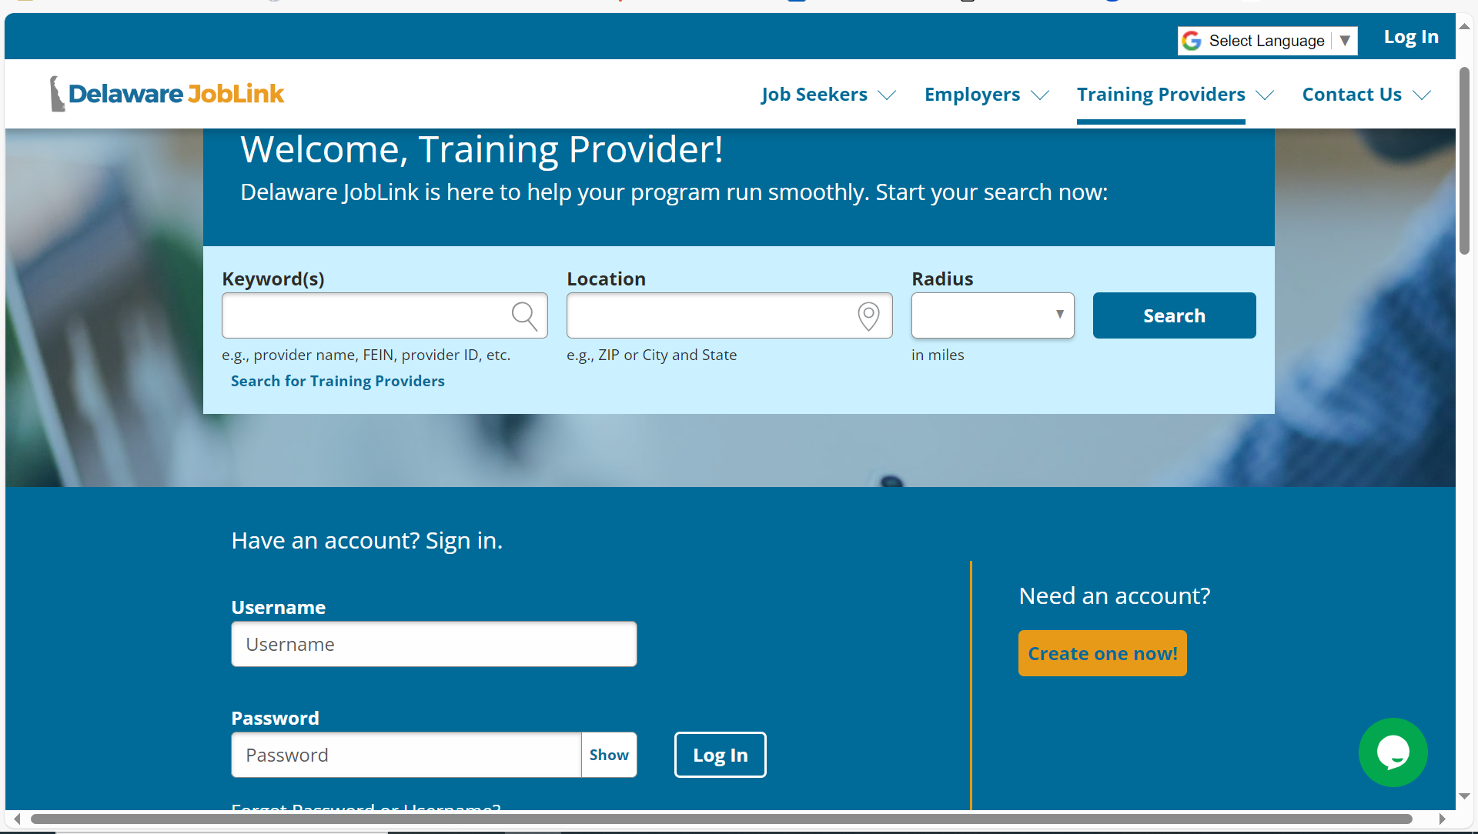

For New Training Providers you must enter your FEIN and search to make sure your facility is not listed in ProviderLink.

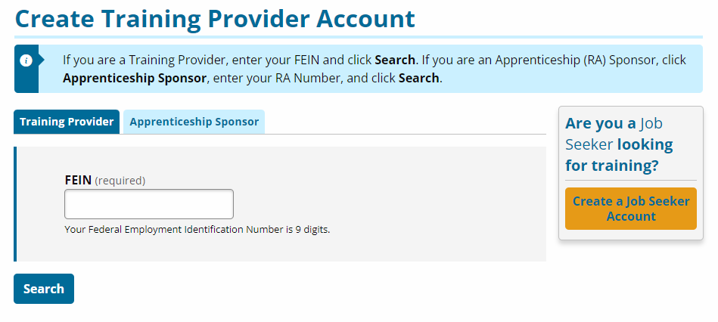

If the facility is not in ProviderLink, click +add a New Provider

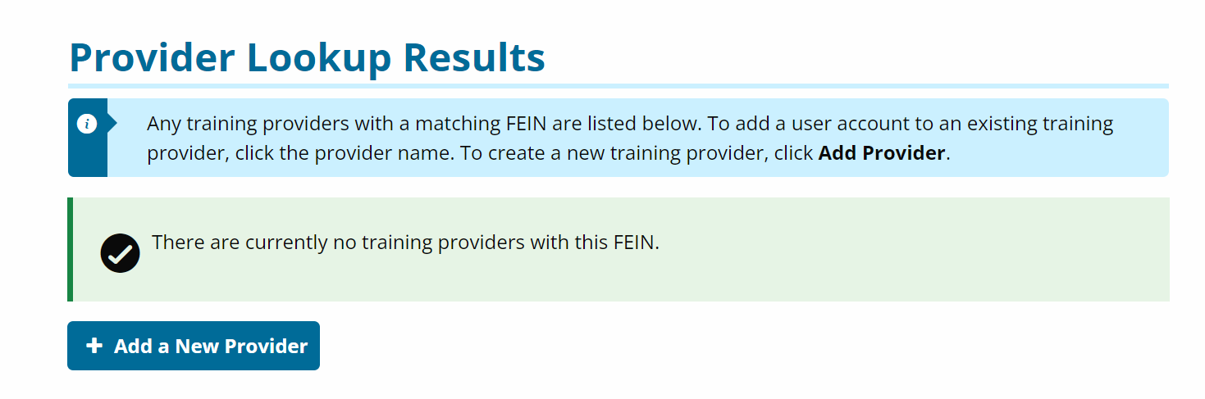

Review the Delaware JobLink- Eligible Training Provider- Assurances and hit accept.

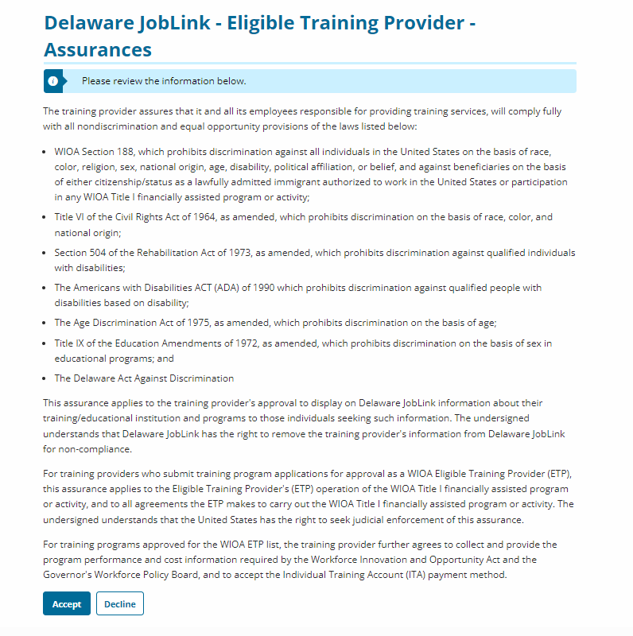

Create Training Provider Account. Make sure to complete all fields (more than what is shown in the visual below) and hit continue.

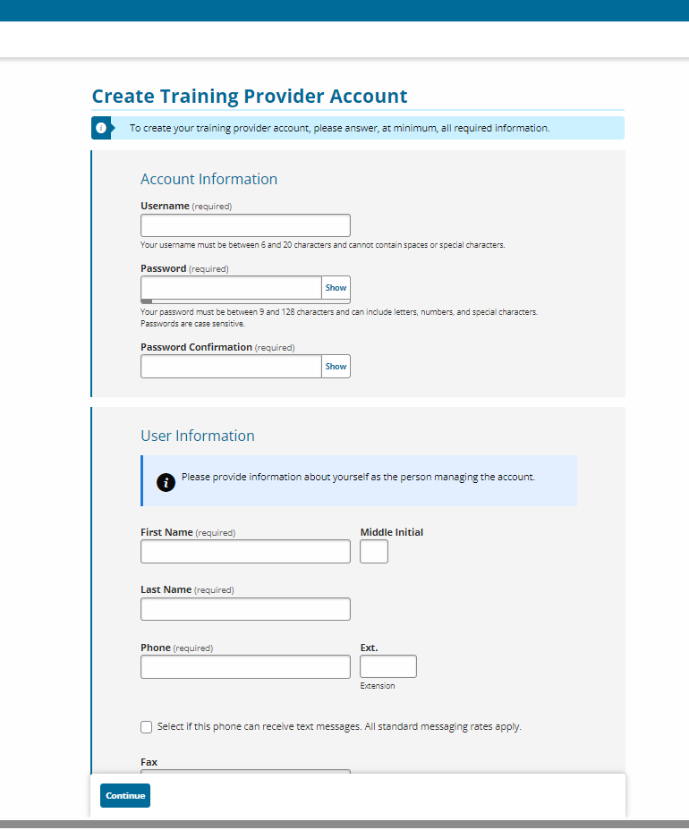

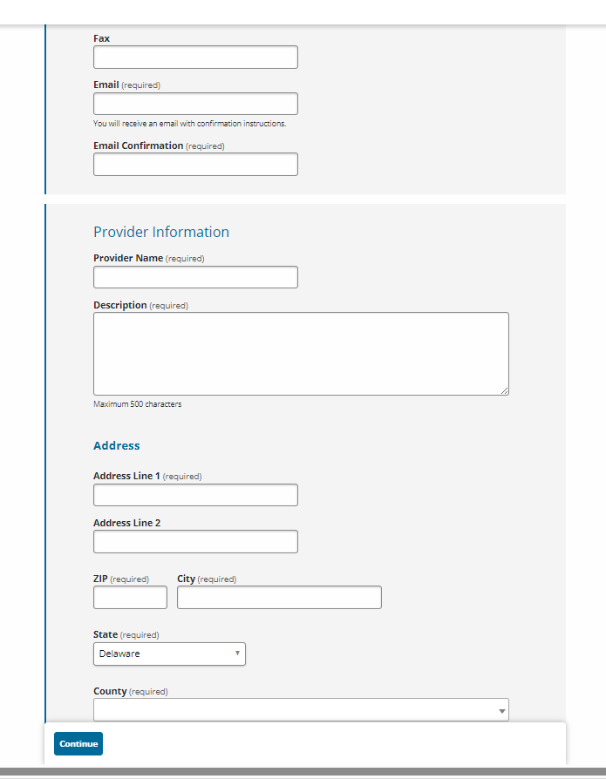

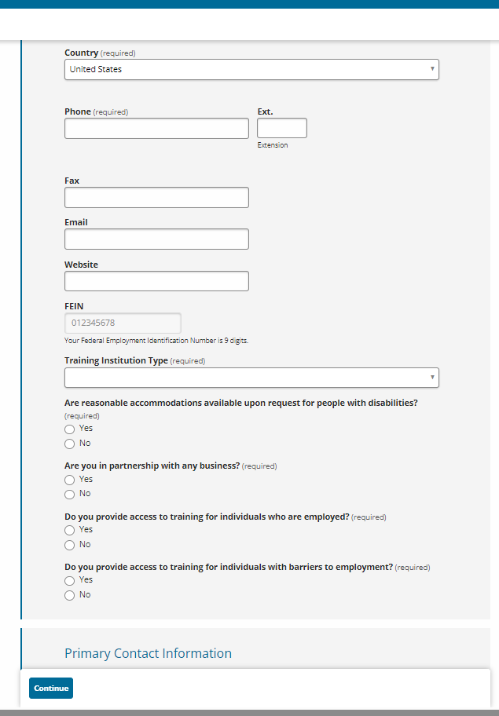

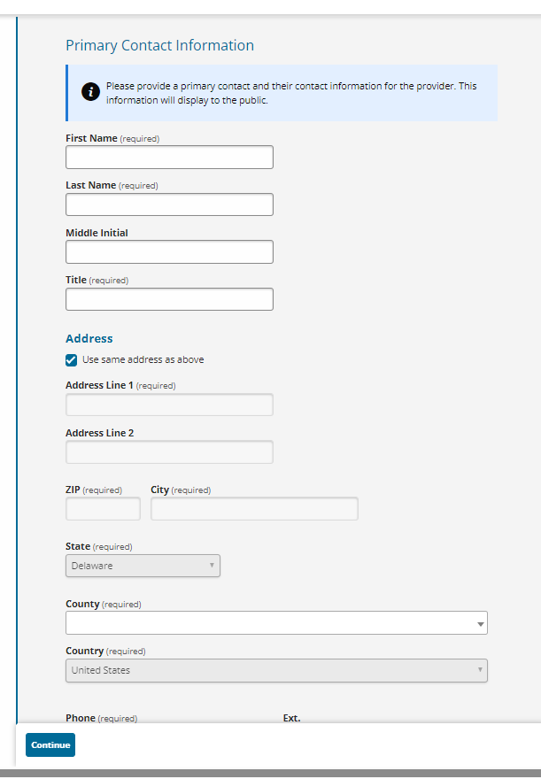

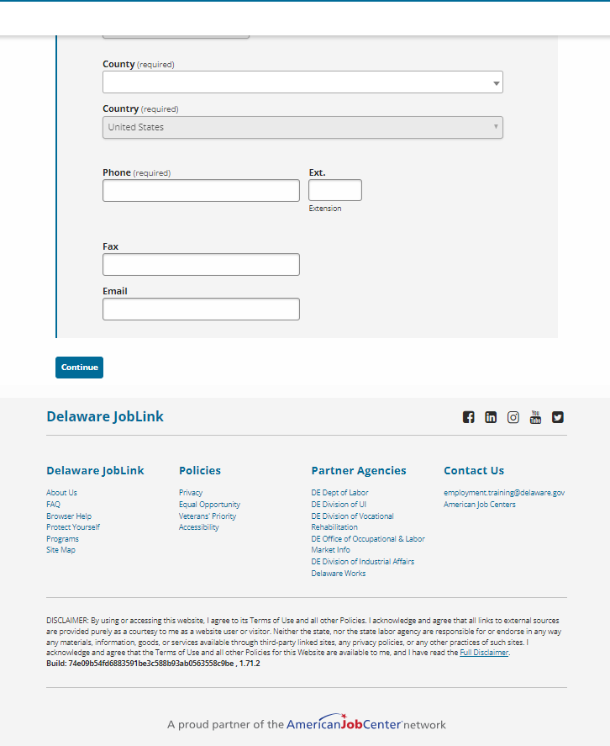

## Entering a New Program to DJL

Log into your profile. Under Manage Programs, click Add Program

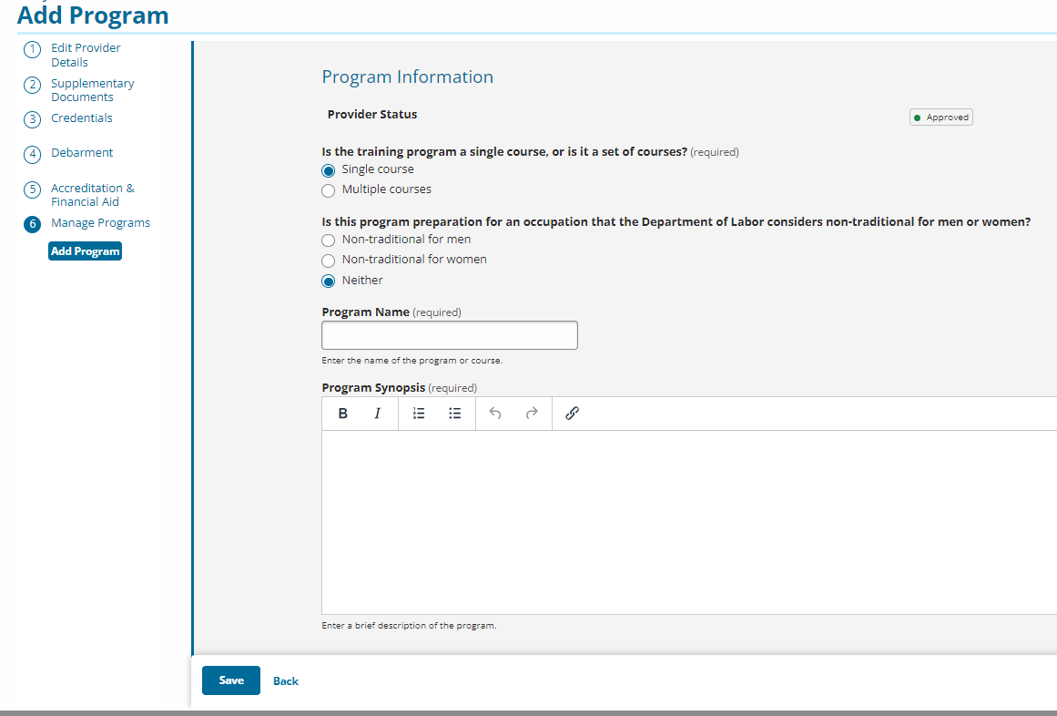

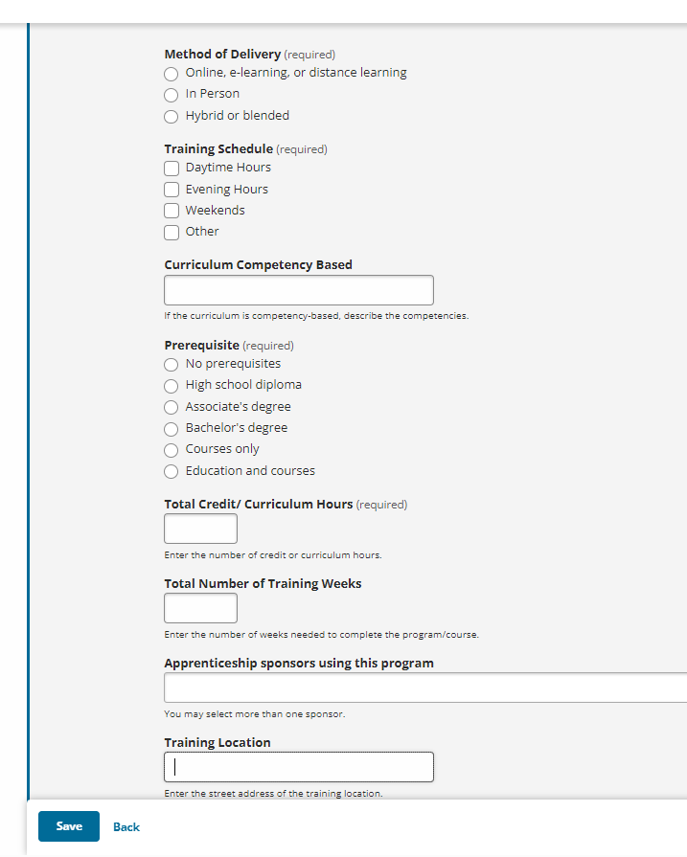

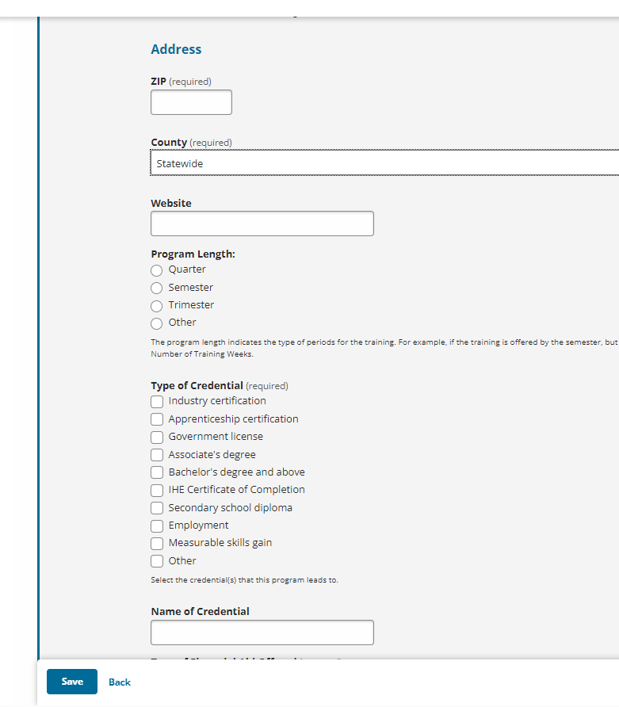

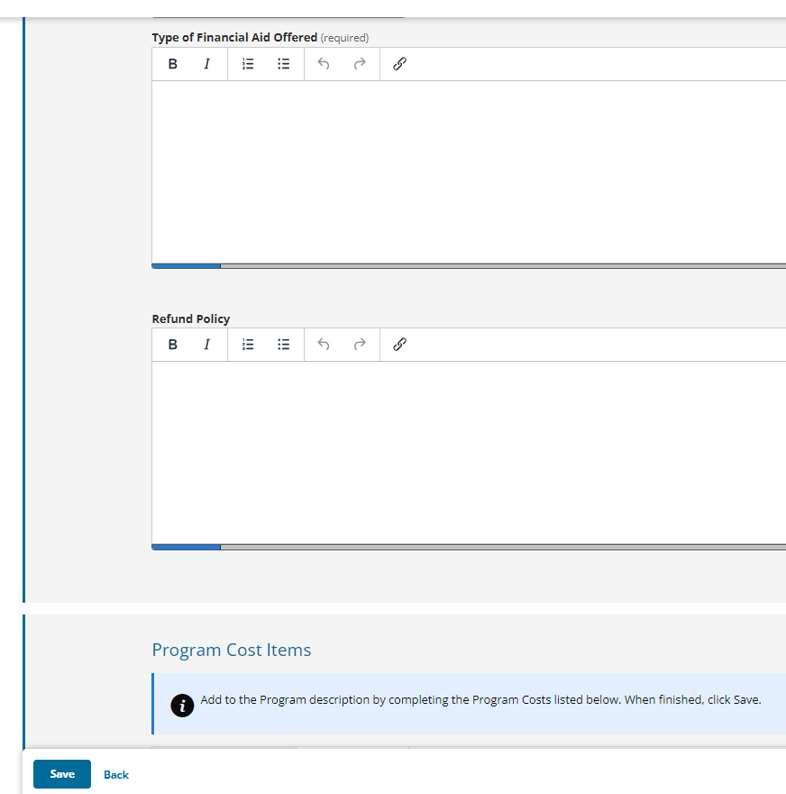

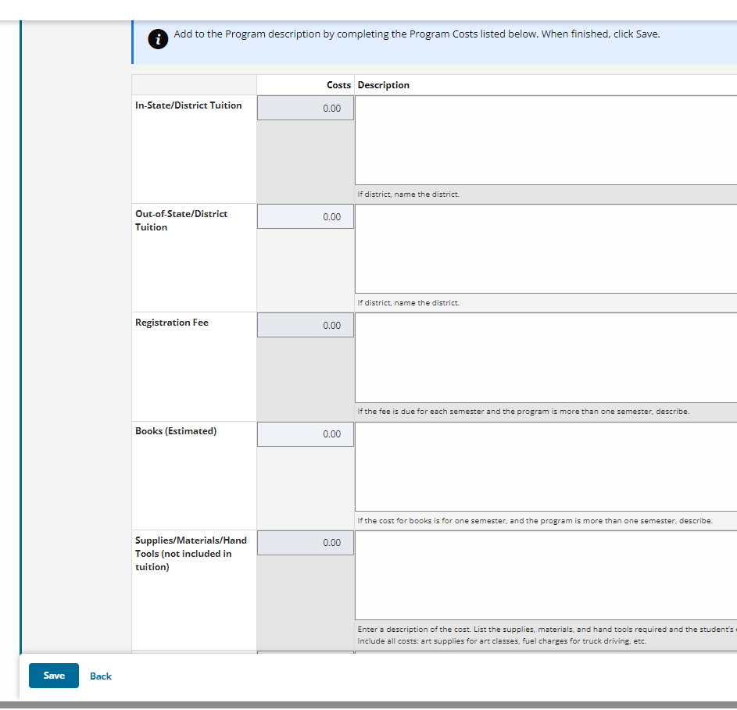

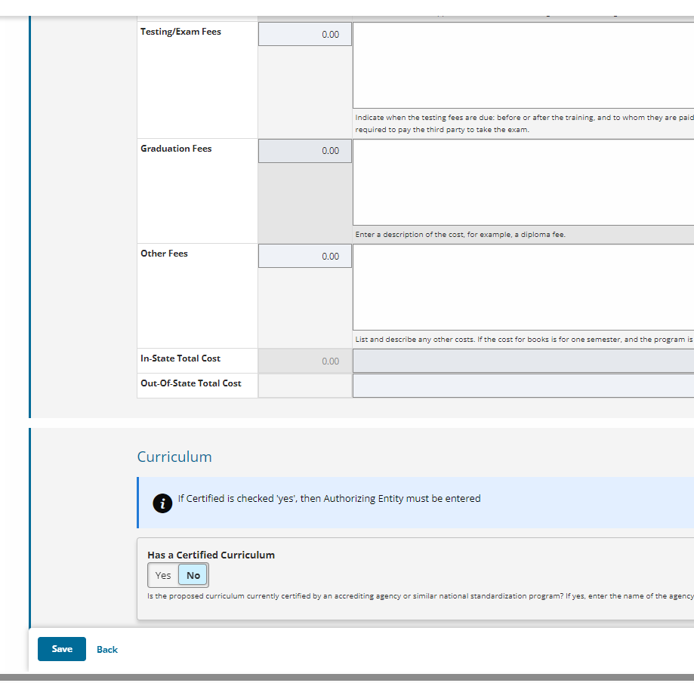

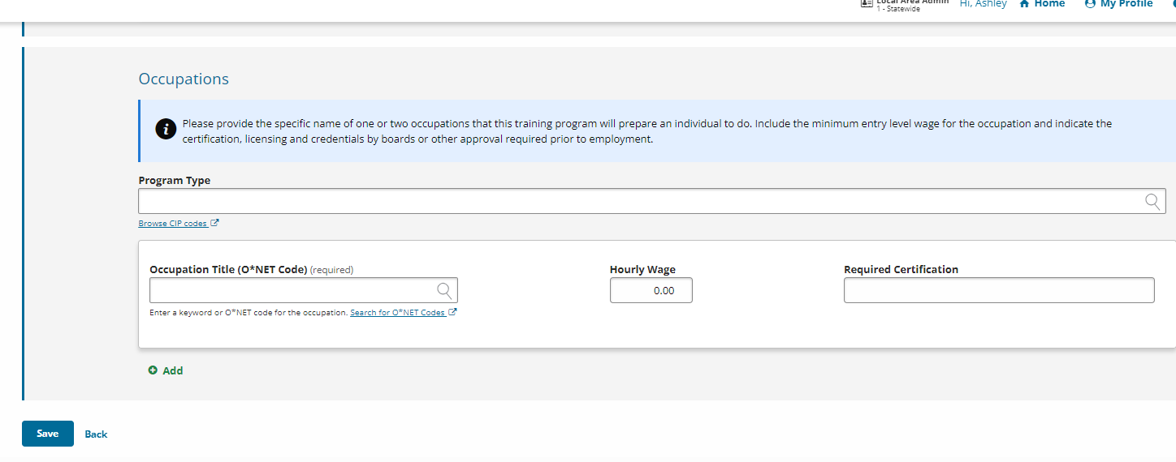

Hit SAVE once all the information is updated.

Entering in performance

In your profile, click Manage Programs

Select the program by hitting Edit under Actions

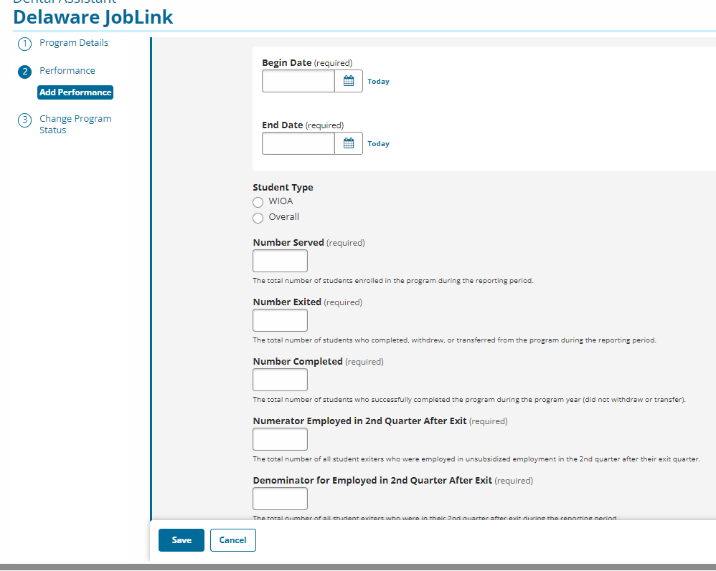

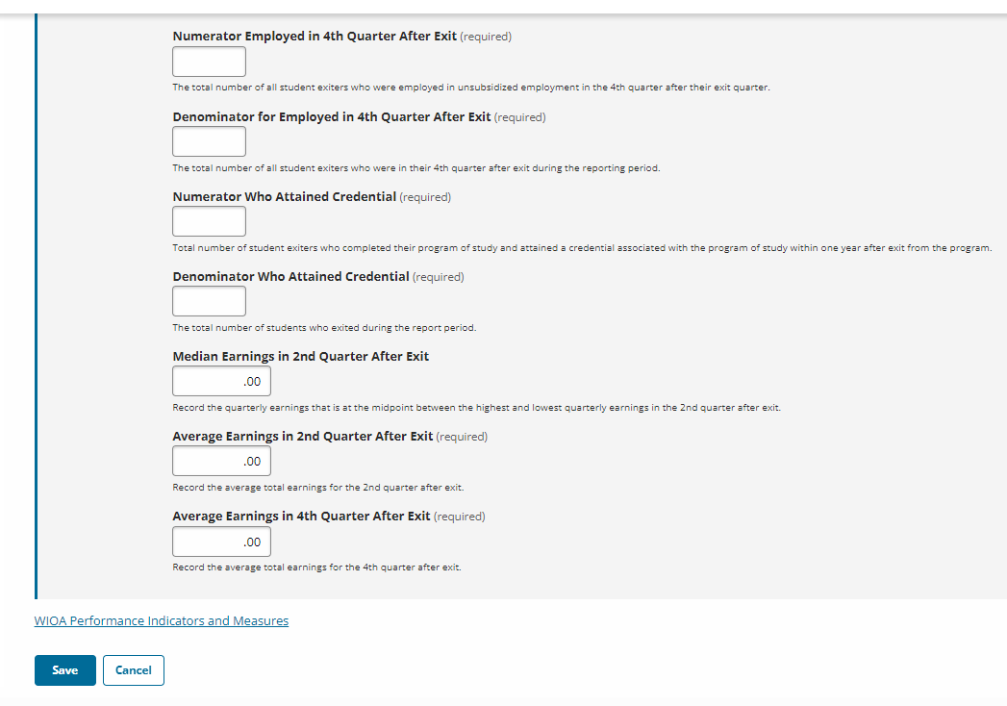

# Appendix B: MOU

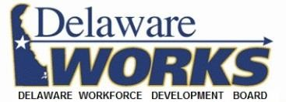

**MEMORANDUM OF UNDERSTANDING**

**ITA Training Providers**

This agreement (Agreement) is made and entered into by and between Delaware’s Workforce Development Board, hereinafter referred to as the (DWDB) and the Training Provider known as

, located at ______________________________, hereinafter referred to as the (Provider).

**WHEREAS** the Workforce Innovation and Opportunity Act (WIOA) requires the DWDB to provide policy guidance and oversight with respect to workforce development activities, including identification of eligible training providers, who may receive payment of Individual Training Account federal funds if they meet initial as well as subsequent requirements of Title 1 of WIOA.

**NOW, THEREFORE, BE IT RESOLVED** that the following Agreement between the DWDB and the above-mentioned Provider shall, when signed, constitute a proper and valid agreement between the two parties for the purposes of governing each parties’ obligations under WIOA, DWDB policies, minimum renewal requirements, and required performance data.

A training provider must qualify as one of the following to meet the definition of an eligible training provider:

1. Institute of higher education that provides a program of training that leads to a recognized postsecondary credential.
2. Entity that carries out program under the Registered Apprenticeship.
3. Public or private training providers, which may include community-based organizations (CBOs) and joint labor-management organizations.
4. Provider of adult education and literacy activities if such activities are provided concurrently or in combination with other training services.

Delaware Workforce Development Board will:

1. Provide the High Demand Occupation List, comprising essential occupations required to address market demands, along with approved training programs approved by DWDB. This list is developed in collaboration with the Office of Occupational and Labor Market Information, Delaware Department of Labor.
2. Make available a comprehensive training list of programs through the reporting system that is maintained as part of Delaware JobLink (DJL) to allow for informed customer choice.
3. Make available written documentation of approved Provider and programs to the Eligible Training Provider List.
4. Place programs in hold status if:
   1. complaints are received; or
   2. if providers are identified in notices of non-compliance with other State Agencies, including divisions with Department of Labor (Unemployment Insurance, Industrial Affairs, or Employment and Training) and Division of Small Business; or
   3. if Provider’s required documents are out of date.
5. Ensure payment for the approved Individual Training Account when submitted by a current eligible training provider for an approved program.
6. Reserves the right to visit the Provider (announced and unannounced) to monitor programs to ensure compliance with federal and state policies and regulations.
7. Remove Provider and or Provider’s programs from the State list of eligible training providers if Provider:
   1. is determined by DWDB to have intentionally supplied inaccurate information or to have substantially violated any provision of Title I of WIOA or the WIOA regulations;
   2. substantially violates requirement to timely and accurately report performance data as required by the DWDB;
   3. substantially violates the requirement to timely and accurately meet annual renewal deadlines or any other deadlines as required by the DWDB;
   4. fails to comply with other applicable state or federal laws or regulations, including state labor laws;
   5. program(s) do not meet prescribed performance measures or if program(s)fail to meet prescribed eligibility criteria;
   6. does not provide quality training, as determined by DWDB, or does not provide training according to the contracted information listed in DJL submitted by Provider in support of this Agreement;
   7. does not adhere to any corrective action plan imposed on Provider by DWDB;
   8. fails to comply with this Agreement.
8. Prior to removal of a Provider or program from the eligible training provider list, DWDB will work with Provider to come into compliance through a corrective action plan.
9. Remove Provider and Provider’s programs that fail to comply fully with the nondiscrimination and equal opportunity provisions [of Section 188 of Workforce Innovation and Opportunity Act (WIOA) and 29 CFR Part 38](https://www.ecfr.gov/current/title-29/subtitle-A/part-38), or any other laws regarding WIOA title 1 financially assisted programs and activities.
10. Provide one set of Equal Opportunity posters (three sets, in English and Spanish, 11X17 format), instructions, templates for posters, and updates to contact information for all designated EO Officers to Provider for providing WIOA-required Equal Opportunity notifications.
11. Provide technical assistance to Provider regarding compliance with WIOA, WIOA Regulations, this Agreement, DWDB policies and DWDB letters of instruction for Provider.

Responsibilities of the Provider:

1. Meet all eligibility criteria and provide all required documentation set forth in the DWDB Eligible Training Provider List (ETPL) Approval Criteria posted on the DWDB website, both initially and at each renewal period, for each program. In order to remain eligible, Provider’s required documents must be up to date and in compliance with state laws. It is the sole responsibility of the Provider to maintain current documents. Providers can be temporarily removed or deactivated if required documents are not up to date.
2. Maintain a Delaware Department of Education approval as indicated in [Title 14](https://delcode.delaware.gov/title14/title14.pdf), Chapter 85 of Delaware Code. The certificate of approval must be provided to DWDB upon initial eligibility and each calendar year thereafter or otherwise upon expiration of the prior certificate. Providers who do not meet this requirement because they are specifically excluded from [Title 14](https://delcode.delaware.gov/title14/title14.pdf), Chapter 85, Section 8529 must notify the DWDB in writing.
3. Maintain compliance with all State of Delaware agencies. This includes Delaware Department of Labor, Division of Unemployment Insurance, Industrial Affairs, and Division of Employment and Training, and Division of Small Business. Compliance includes, but not limited to, wage and hour, workers’ compensation, special assessment referred to as Employment and Training Fund tax.
4. Offer programs that:
   1. are currently available in the Provider’s course catalog and/or website and in use by the general public on a tuition basis and make those programs available to the DWDB at the same or lower tuition;
   2. provide training according to the information and terms set forth in the program profile in DJL submitted by Provider in support of this Agreement, including but not limited to tuition total costs and training hours (internships/externships, lab, yard, or field hours).
   3. offer training/education and an industry approved credential for an occupation that is in demand by the current local labor market, listed as a high demand occupation on the High Demand Occupation list as designated by DWDB;
   4. ensure participants are provided quality education and training that will result in an industry recognized certificate or credential, a certificate of completion of a registered apprenticeship, a license recognized by the State of Federal government, or an associate or baccalaureate degree;
5. Have a physical Delaware address, or if out of state training provider, must first be included on that state’s ETPL.
6. Have a refund policy specifying when refunds for tuition and other costs associated with the training program will be allowed. Refund policies must be written and published in DJL to ensure students are aware of how to request a refund.
7. Have a grievance policy that provides due process for student to file complaints with an organization against faculty, staff, or other employees. Grievance policies must be written and published to ensure students are aware of how to file a complaint.
8. Retain sufficient and qualified instructional and administrative staff ([Title 14 Delaware State Code](https://delcode.delaware.gov/title14/title14.pdf)). Notify DWDB of any personnel changes related to the training.
9. Ensure there are sufficient financial resources in place to guarantee that participants receive instruction, necessary materials, etc., until payment is received from the state.
10. Meet or exceed the state mandated performance requirements.
11. Submit reports or requests in a timely and accurate manner. This includes:
    1. all performance measures as outlined in the annual letter of instruction from DWDB, including median earnings, job placement, retention, and completion rates as stated in [20 CFR 680.460](https://www.ecfr.gov/current/title-20/section-680.460) (g). Failure to attain performance measures may result in probation and a corrective action plan, or in removal of the program;
    2. reporting performance data within 15 days of the close of the quarter (Quarter close dates are June 30, September 30, December 31, and March 31);
    3. providing the requested renewal data to DWDB no later than the deadline outlined in the letter of instruction for all programs that are subject to renewal. Programs which do not have their renewal data submitted by the deadline will be ineligible for funding on or after the July 1st renewal date. Programs approved after December of any given year are subject to consideration for renewal the following year; and
    4. Submitting invoices for payment as directed by DWDB within 90 days after the course drop/add date.
12. Follow DWDB instructions to enter programs and other necessary information into DJL and update DJL only during the renewal period unless otherwise stated. This includes all fees associated with the program including tuition, books, exam fees, and other related costs. Fees must be itemized in the cost description area in DJL under Program Cost Items.
13. Immediately report to the DWDB and update Provider profile in DJL of any changes in address for training location, clinical practice, or administrative offices that are associated with the training program.
14. Have a stable training facility location and a local land line telephone number. While the DWDB understands that the business world is dynamic and things change, it also understands that training facility stability is an indicator of a successful and viable organization. The DWDB may suspend any organization that moves without notification twice in the same 12-month period, as the Provider will be out of compliance with this Agreement.
15. Comply fully with the nondiscrimination and equal opportunity provisions of [Section 188 of Workforce Innovation and Opportunity Act (WIOA) and 29 CFR Part 38](https://www.ecfr.gov/current/title-29/subtitle-A/part-38), or any other laws regarding WIOA title 1 financially assisted programs and activities.
16. Comply with posting Equal Opportunity is the law posters in reasonable number of places, in available and conspicuous physical locations, and providing WOIA-required Equal Opportunity notifications to Registrants, eligible applicants, participants, claimants, employees, applicants for employment, and interested members of the public.

Failure to comply with these responsibilities may lead to suspension or removal of a program and/or a Provider from the State’s eligible training provider list. Any removal of a program or Provider will be subject to the appeal opportunities provided in the ETPL Appeal Process Policy, which is posted on DWDB’s website.

General Provisions:

1. This Agreement shall be governed by WIOA, the WIOA regulations and other applicable federal and State of Delaware laws and regulations.
2. Removal of a program or Provider from the State list of eligible training providers by DWDB will be subject to the ETPL Appeal Process Policy which is posted on DWDB’s website.
3. If any complaint is filed against Provider by a participant in training funded pursuant to this Agreement, DWDB will investigate and process the complaint pursuant to the Client Complaint/Appeal Procedures policy, which is posted on the DWDB website.
4. As part of the renewal process, DWDB will remove programs that fail to meet the established eligibility criteria at the time of renewal, which may include failure to meet established minimum performance levels. All Eligible Training Providers (ETPs) are required to report performance data requested by the State/DWDB. In addition to the data that must be provided on the WIOA participants being served by that program, WIOA section 116(d)(4) requires that ETPs provide the necessary information to the State/DWDB on all individuals being served in the approved program.
5. If an ETP request to be removed from the ETPL and a program appears on the ETPL during a given reporting period (between July 1 – June 30), providers will still be required to submit data for that program whether or not WIOA participants were enrolled in that program.  For information purposes only, providers will remain on the distribution list until reporting period is complete.
6. Nondiscrimination. As a condition to the award of financial assistance from DWDB under Title I of WIOA, Provider assures that it will comply fully with the nondiscrimination and equal opportunity provisions of the following laws:
   1. [Section 188 of the Workforce Innovation & Opportunity Act of 2014](https://www.ecfr.gov/current/title-29/subtitle-A/part-38) (WIOA), which prohibits discrimination against all individuals in the United States on the basis of race, color, religion, sex, national origin, age, disability, political affiliation, or belief, and against beneficiaries on the basis of either citizenship/status as a lawfully admitted immigrant authorized to work in the United States or participation in any WIOA Title I financially assisted program or activity;
   2. [Code of Federal Regulations (CFR) 29 CFR Part 38](https://www.ecfr.gov/current/title-29/subtitle-A/part-38#part-38)
   3. [Title VII of the Civil Rights Act of 1964](https://www.eeoc.gov/statutes/title-vii-civil-rights-act-1964), as amended, which prohibits discrimination on the bases of race, color, and national origin; Section 504 of the Rehabilitation Act of 1973, as amended, which prohibits discrimination against individuals with disabilities;
   4. [The Age Discrimination Act of 1975](https://www.dol.gov/agencies/oasam/regulatory/statutes/age-discrimination-act), as amended, which prohibits discrimination on the basis of age; and
   5. [Title IX of the Education Amendments of 1972](https://www.justice.gov/crt/title-ix-education-amendments-1972), as amended, which prohibits discrimination on the basis of sex in educational programs.

This Agreement indicates an agreement between the **Provider** and the **DWDB.** Any disagreement between parties affecting this Agreement shall be resolved by mutually satisfactory negotiations. In addition to the ability to immediately remove or suspend a Provider or a program based on terms of this Agreement, either party may cancel the Agreement with a 60-day written notice. This Agreement shall be in effect until it is replaced by a mutual agreement of both parties and/or cancelled by either party.

We, the undersigned, an authorized representative of Provider with authority to enter into this Agreement and the Executive Director of DWDB, enter into this Agreement on the day of _______, 2024

|  |  |
| --- | --- |
| Provider Authorized Signature | DWDB Signature |
| Print Name: | Print Name: |
| Title: | DWDB Executive Director  Title: |
| Provider Phone Number | DWDB Phone Number |

# Appendix C: Initial Application Policy

Eligible Training Provider List—New Application Requirements

**Introduction:** To maximize customer choice and assure that all population groups are served, a comprehensive process must ensure that a significant number of qualified Eligible Training Providers (ETPs) are available to customers. Reference § 680.450 and TEGL 8-19.

**Policy:** Prospective providers can submit applications anytime; however, only the Proposal Review and Certification Committee may recommend approval of a provider and its programs to the Executive Committee or Full Board. For the initial eligibility screening, DWDB staff shall complete of an initial monitoring visit form. DWDB staff will make an onsite visit to the prospective provider’s training site to gather information for the form. The visit will determine whether the provider’s facilities are adequate, are safe, and reflect an atmosphere appropriate to the trade being taught.

After the initial screening is completed, the provider will receive via email a .pdf copy of “The Provider Link User Guide.” The provider must complete their provider profile application within Delaware Job Link (DJL). The DWDB staff will only accept complete applications from prospective providers. Complete applications in (DJL) must include:

1. A signed Memorandum of Understanding;
2. A complete information profile for each program with verifiable program-specific information and a statement of course costs and fees that match the course catalog used by the public;
3. Information supporting the provider’s partnership with business, which may include information about the quality and quantity of employer partnerships;
4. Debarment disclosure;
5. Delaware Department of Education Certification;
6. A demonstration of at least one-year of experience training job seekers in high demand occupations and an established a track record in course completion and job placement;
7. A financial statement prepared by an accounting firm or a signed tax return; and
8. A copy of the provider’s current business license.

DWDB staff will recommend to the Proposal Review and Certification Committee approval/non-approval of initial applications for providers. Following provider approval, staff will inform the provider they can enter programs into DJL for consideration. The staff will review all the programs and develop recommendations for program approval based on, at least, the following criteria:

1. Does the provider program meet a high demand occupation?
2. Does this provider have an established track record of success for at least one year conducting training and job placement?
3. Does the program offer industry-recognized certifications and credentials?
4. Does the program lead to a recognized post-secondary credential?
5. Does the provider have enough revenue to succeed without the ITA funding?
6. Is the training site equipped to conduct training?
7. Can the training site switch to remote learning if necessary?
8. Does the provider offer trainings that are physically and programmatically accessible for individuals who are employed and individuals with barriers to employment including individuals with disabilities?
9. Are the programs submitted for approval currently available and ready for public use?

The Proposal Reviewed and Certification Committee may accept or reject the staff’s recommendations in whole or in part. The Committee is free to accept all prospective programs, some programs, or no programs and will present its decision to the Executive Committee or Full board.

When a program or provider is approved by the Executive Committee or Full Board, the DWDB staff will notify the provider of the approval via email.

The DWDB executive director will notify, in writing, via email non-approved providers or programs of the decision. At a minimum the letter will:

1. Be sent to providers via email within 30 days of the committee’s decision;
2. Clearly inform providers of their opportunity to appeal;
3. Have the appeal process as a standalone attachment to the letter/email; and
4. Generally, explain the reason for non-approval.

Providers must collect and provide the following performance metrics based on aggregate data for **all** students in the program to ensure the program supports the ability for the individual to obtain an industry-recognized postsecondary credential, or employment upon completion of the program. This includes:

* 1. Employment 2nd & 4th quarter after exit;
  2. Median earnings;
  3. Credential attainment;
  4. Total number of participants enrolled in the program;
  5. Total number of participants completing the program; and
  6. Total number of participants exiting the program.

In establishing eligibility criteria, Delaware will take into consideration information reported to State agencies on Federal and State training programs other than programs within WIOA Title I, subtitle B. Eligible training providers receive initial eligibility for only one year for a particular program. Reference: WIOA § 122(b)(4)(B).

After the initial eligibility expires, the initially [eligible](https://www.law.cornell.edu/definitions/index.php?width=840&height=800&iframe=true&def_id=efacf5417ca52732fda8830a7c27ba15&term_occur=999&term_src=Title:20:Chapter:V:Part:680:Subpart:D:680.450) training providers are subject to the  application procedures for continued eligibility. Reference: [§ 680.460](https://www.law.cornell.edu/cfr/text/20/680.460).

Registered Apprenticeships: All registered apprenticeship (RA) programs are automatically eligible to be included on the statewide ETPL. RA programs are not subject to the same application requirement, performance-information requirement, or period of initial eligibility procedures because they have already gone through a detailed application and vetting process. Reference: 20 CFR § 680.470.

The information required for an RA program to be added to the ETPL is:

1. Occupations included within the registered apprenticeship program;
2. Name and address of the RA Program sponsor;
3. Name and address of the related technical instruction provider, including the location of the facility if different from the program sponsor's address;
4. Method and length of instruction; and
5. The number of active apprentices.

Out of state training providers: The DWDB will only accept applications from training providers whose training facility is located out of state if:

1. The training provider and program is listed on the home state’s ETPL.
2. If Delaware does not offer the training.

Delaware encourages Delawareans to use Individual Training Account vouchers for in-state providers and programs. DWDB will evaluate new out of state provider applications on a case-by-case basis.

# Appendix D: Subsequent Renewal Policy

Eligible Training Provider List (ETPL)—Renewal Application and Continuing Eligibility Requirements

**Introduction:** Retaining quality providers and ensuring provider stability is in the best interest of the Delaware Workforce Development Board (DWDB). To ensure Delawareans have access to training, which will give them a competitive edge in the labor market, it is essential the DWDB review providers, including their performance, to ensure only the best are renewed. This may result in longtime providers or select programs being removed from the list. Programs are removed from the list for two years. Providers may reapply on the two-year anniversary of the removal of a specific program. Reference 20 CFR § 680.460.

Training providers, who currently have programs listed on the ETPL and want to have their programs remain on the ETPL, must follow the procedures for continuing eligibility determination as follows and in the timeframe and manner determined by the state:

1. Review each approved program in Delaware Job Link (DJL). The provider must:
   1. update provider information;
   2. Update information on each program pertaining to alignment of training with in-demand occupations, which must include a cost information for the program, such as tuition, registration fee, books, supplies, testing/exam fees, and graduation fees; and
   3. update program data.
2. Attend the provider forum.
3. Submit all student performance data as referenced in WIOA sections 116 and 122 in a timely and accurate manner. This includes:
   1. employment 2nd & 4th quarter after exit;
   2. median earning;
   3. credential attainment;
   4. total number of participants enrolled in the program;
   5. total number of participants completing the program; and
   6. total number of participants exiting the program.
4. Meet the previous year’s performance objectives.
5. Offer training programs which support demand occupations.
6. Update all contacts and emails.
7. Describe how the provider will ensure access to training services throughout the State, including rural areas and through the use of technology.
8. Address provider’s ability to offer industry-recognized certificates and credentials.
9. Provide information on recognized post-secondary credentials received by program participants.
10. Describe quality of the program of training services including a program that leads to a recognized postsecondary credential.
11. Describe the provider’s ability to provide trainings that are physically and programmatically accessible for individuals who are employed and individuals with barriers to employment, including individuals with disabilities.
12. Submit all state licensure requirements of training providers and licensing status of providers of training services, if applicable.
13. Submit a true and correct copy of the most recent audited financial statements or a signed and filed tax return.

When a provider submits its renewal application within DJL, the DWDB staff will check the performance measures. Training providers will be required to submit student level performance data on **ALL** participants in listed programs each year for inclusion on ETPL. This information will be submitted through the DJL program profile. Required performance indicators are employment second and fourth quarter after exit, median earnings, and credential attainment. Programs cannot be approved until data submission has been accepted and passed necessary validation of completion. The DWDB staff will flag any performance measure failure of a subsequent program renewal application for removal from the provider list.

Providers that wish to self-remove a program must fill out and submit a program removal form to DWDB staff prior to renewal date (typically July 1).

DWDB staff will recommend to the Proposal Review and Certification Committee approval or non-approval for providers and specific programs. Notably, successful programs no longer training high demand occupations are subject to non-renewal. The Proposal Review and Certification Committee will make recommendations to the Full Board or Executive Committee to remove the program from the list.

The Proposal Review and Certification Committee may only renew programs that achieve the performance measures, but the Committee may otherwise accept or reject all of the staff’s other recommendations, in whole or in part. The Committee is free to accept all programs, some programs, or none of the programs.

When the Board or Executive Committee approves a subsequent renewal, the DWDB will notify the provider. The DWDB Executive Director will notify, in writing, non-approved providers or programs of the decision. At a minimum the letter will:

1. Be sent to providers via email within 15 days of the decision; and
2. Clearly inform providers of their opportunity to appeal.

In establishing eligibility criteria, Delaware will take into consideration information reported to State agencies on Federal and State training programs other than programs within WIOA Title I, subtitle B.

Out of state training providers: The DWDB will only renew applications from training providers whose training facility is located out of state if:

1. All of the above renewal requirements are met.
2. The training provider and program is listed on the home state’s ETPL.
3. If Delaware does not offer the training.

Delaware encourages Delawareans to use Individual Training Account vouchers for in-state providers and programs. DWDB will evaluate new out of state provider applications on a case-by-case basis.

# Appendix E: Adding Registered Apprenticeship (RA) Program Sponsors to the Eligible Training Provider List (ETPL) Policy

**Introduction:** All Registered Apprenticeship programs that are registered with the U.S. Department of Labor, Office of Apprenticeship, or a recognized State Apprenticeship Agency, are automatically eligible to be included in the State list of eligible training providers and programs. RA program sponsors that request to be an ETP are automatically included on the State’s ETP list and will remain as long as the program is registered and active or until the program sponsor notifies the State that it no longer wants to be included on the list. References: US DOL Regulation 680.470 dtd. August 19, 2016, Procedures For Including And Removing Registered Apprenticeship Programs On A State List Of Eligible Training Providers And Programs.

**General:** Inclusion of a registered apprenticeship in the State list of eligible training providers and programs ensures job seekers are aware of registered apprenticeship opportunities and maximizes the program’s visibility within the workforce system and allows an individual who is eligible to use WIOA title I, subtitle B funds to use those funds toward registered apprenticeship training.

**Procedure:** The Delaware Workforce Development Board (DWDB) establishes this process for including registered apprenticeship programs on Delaware’s State list of eligible training providers and programs. When initial acknowledgment of acceptance as a sponsor of Registered Apprenticeship has been issued by the State Apprenticeship Agency, the registered apprenticeship sponsor is invited to join the ETP list. The State Agency will provide the following required information:

1. Sponsor Name
2. Sponsor Address
3. Sponsor Phone Number
4. Sponsor Fax Number
5. Contact Name and Title
6. Contact Number
7. Occupation(s) included in the Registered Apprenticeship program
8. Name and Address of the Related Technical Instruction provider (if different from the sponsor’s location)
9. The method and length of instruction
10. The number of apprentices (active, non-active, all)

The DWDB Staff will:

1. Work with the State Agency and RA to enter the required information in Delaware JobLink, which will be visible to the general public on the Statewide List of Eligible Training Providers.
2. Provide guidance to the sponsor with any questions regarding WIOA and its key provisions, such as the State list of ETP’s, State Workforce Board and other aspects of the system.
3. The DWDB Executive Director will notify the sponsor, in writing, that they are now listed on Delaware’s Statewide List of Eligible Training Providers.

The State Apprenticeship Agency will update the DWDB on the status of Registered Apprenticeship programs in order to ensure that it remains certified and removes any apprenticeship programs from the ETPL that are no longer registered either voluntarily or involuntarily deregistered.

Delaware has an MOU with Unemployment Insurance to support the collection of wage information for non-WIOA students. WIOA student data is collected by case managers.

Delaware requires providers to timely and accurately submit all required information within 30 days of the close of the quarter.

# Appendix F: Monitoring Policy

**Introduction:** The Delaware Workforce Development Board (DWDB) has established an oversight and monitoring process that includes an annual onsite review of all program providers through monitoring visits and ongoing reviews of Eligible Training Providers List (ETPL). These activities are required to fulfill the oversight responsibilities in accordance with the Workforce Innovation and Opportunity Act (WIOA). Recipients are responsible for managing the day-to-day operations of the federal and state funding they receive. To fulfill their role as a steward of federal and state funds, DWDB staff monitors to identify potential problems and areas where technical assistance or corrective action might be necessary.

**Policy:** Monitoring is performed through desk reviews and onsite visits. Monitoring activities include:

* A review of program and participant services to include the intake and referral process, eligibility certification, priority of service, registration, objective assessment, classroom training, on-the-job training, work experience, and supportive services;
* A review of program administration and management practices, including fiscal and accounting procedures, reporting, internal control systems (*e.g.*, protection of personally identifiable information (PII)); and
* A review of nondiscrimination and equal opportunity (EO) policy and procedures.

**Frequency of Monitoring**

Programmatic and fiscal monitoring is conducted each year with a minimum of one on-site visit per year. EO WIOA Section 188 monitoring is conducted once per year.

Due to the complexity of each funding source’s compliance requirements, all newly funded providers will receive additional guidance in the form of an orientation site visit and initial site visit. DWDB reserves the right to conduct additional site visits as necessary.

Site visits can consist of the following types:

**Pre-monitoring Site Visits**

**Procedure:**

1. Before final approval of a new provider, DWDB will conduct a pre-monitoring site visit. The purpose of this visit is to determine the organization’s capacity for meeting the application requirements and minimum standards for training services.
2. The review will be consistent with the regular monitoring DWDB conducts on its providers. Anything that the potential provider does not have in place, it must either develop according to the timelines set by DWDB or demonstrate its capacity to meet the requirement.
3. The site visit will be followed by a site-visit report to be completed as soon as possible, but no later than 30 business days after the visit. The report will include timelines that potential provider must adhere to receive application approval.
4. If deadlines are not met by the organization or if the documentation provided is inadequate, DWDB may deny implementation of the application with the organization. DWDB may also deny application initiation with the organization if the pre-monitoring site visit causes DWDB to conclude that the organization does not have sufficient capacity to meet the application obligations or meet minimum standards.
5. DWDB will work with the organization as much as possible to assist them in the understanding the requirements of the application and site visit report. DWDB will provide trainings when possible and as needed by the organization to meet requirements.

**Orientation Site Visit**

**Procedure:**

1. Within three months of a provider commencing services, DWDB may schedule an orientation site visit with the provider. DWDB might not conduct the orientation site visit if DWDB determines that all the items to be reviewed and the information needed by the provider were covered during the pre-award site visit.
2. The site visit is an opportunity for the administration organization staff to make introductions with the provider and give an overview of the roles and responsibilities of the administrative organization and the provider. Administrative organization staff will review the polices, monitoring tools, data requirements, and other application requirements.
3. At a minimum, the orientation site visit will consist of a review of the monitoring tools, the provider’s administrative and programmatic policy and procedure manuals, personnel files, any services specific standards of care, and client files.
4. Each provider must undergo a DWDB accountant review. This review will include reviewing the provider’s fiscal policies and financial records, as well as providing additional technical assistance as needed.
5. DWDB will verify that the provider’s client-satisfaction process is in place.
6. Any recommendations for improvements and any required actions will be documented in a letter to the provider with a timeline. The provider is responsible for addressing those recommendations within the timeline provided. Failure to address the recommendations could result in sanctions, including disallowed expenses for that time.

**Initial Site Visit**

**Procedure:**

1. Within the initial application year, DWDB will schedule an initial site visit.
2. This site visit is an opportunity to evaluate the implementation of compliance guidelines and recommendations from the orientation site visit. Failure to address the required actions from the orientation site visit could result in sanctions.
3. The initial site visit will be a full review using all current monitoring tools including data and fiscal tools.
4. Any findings and recommendations will be documented in a site visit report to the organization as soon as possible, but no later than 30 business days after the visit.
5. Any findings will need to be addressed in a formal plan of corrections in accordance with the plan-of-correction policy.
6. Following the initial site visit, each provider will be monitored according to the DWDB monitoring policy.

**Annual Site Visits**

All providers providing training services funded by the DWDB shall receive one programmatic, pre-arranged site visit each year for the purpose of evaluating application compliance. Additional site visits may be conducted as needed. A formal written report of the site visit findings shall be provided to the provider by DWDB as soon as possible, but no later than 30 business days after completion of the site visit. Providers have 30 business days in which to respond in writing to the findings unless another timeline is given as a part of the site visit report. DWDB retains the right to make unscheduled site visits at any time when the need is indicated by specific circumstances.

**Procedure:**

1. DWDB staff will contact appropriate provider staff to schedule a date for the visit.
2. Written notification of the site visit will be sent to the organization staff 30 calendar days before the visit.
3. A copy of the monitoring tools to be used will be sent to the appropriate staff two weeks before the visit.
4. Monitoring staff will identify the staff to be present and activities planned.
5. The provider will be contacted the week prior to the site visit to confirm date and time of the visit.
6. Providers must confirm date and time of the visit.
7. Providers must submit to DWDB copies of policies requested at least seven calendar days before the scheduled visit.
8. Monitors will conduct desktop audits of the provider prior to the on-site review. The desktop audit may include a review of the timeliness of reports submitted by the provider, a review of organization or program policies and procedures, and a review of information in Delaware Job Links (DJL).
9. Employee or client interviews can be scheduled at DWDB’s discretion, as needed to assist DWDB in determining organization compliance and effectiveness of service delivery. When scheduling and conducing client interviews, DWDB will strictly uphold client confidentiality procedures and ensure that clients fully understand that the interview is completely voluntary and that they may opt out at any time. The monitor will notify the provider in writing that she plans to interview employees or clients. The monitor will include the method for those interviews.
10. Monitoring staff will arrive at the designated provider site visit at the agreed upon date and time with all proper materials for conducting the site visit (site visit evaluation instrument, copy of appropriate sections of application, schedule of provider submissions dates for required reports, etc.).
11. Monitoring staff will meet with the appropriate provider staff to summarize initial findings and recommendations.
12. Monitoring staff will complete a formal written report of the site visit, identifying specific recommendations and findings, and send the report to the provider as soon as possible but no later than 30 business days of completion of the site visit. The report will notify the provider that it must respond to all findings in writing within 30 business days or in another timeframe indicated by DWDB.
13. DWDB staff will evaluate the provider’s written response and notify the provider in writing if the provider response is inadequate in any fashion. Staff shall notify the provider in writing when all findings are properly resolved.
14. The monitor will review the provider response and take further actions if the response is not received within the required timeframe or if findings are not resolved in a timely manner or the provider is otherwise noncompliant.

**Supplemental Site Visits**

Supplemental site visits will be conducted for any established provider as needed to assess compliance with guidelines. The DWDB reserves the right to conduct additional site visits as necessary, and the visits may be announced or unannounced.

**Procedure:**

1. DWDB staff will determine if a supplemental site visit is necessary.
2. DWDB staff will focus the review on newly established compliance criteria and may also review administrative and programmatic policy and procedure manuals, personnel files, client files, and any previous findings.
3. Employee or client interviews can be scheduled at DWDB staff discretion. When scheduling and conducting client interviews, DWDB staff will strictly uphold client’s confidentiality procedures and ensure the clients fully understand that the interview is completely voluntary and that they may opt out at any time.
4. DWDB staff will communicate the results to the provider in the form of a supplemental site visit report as soon as possible but no later than 30 business days.
5. Any findings will need to be addressed in a formal plan of correction.

**Follow-up Site Visits**

When deficiencies are found that warrant additional site visits at a provider, DWDB staff will conduct follow-up site visits to verify that the plan of correction is being implemented. The DWDB reserves the right to conduct additional follow-up site visits as necessary to verify the implementation of a plan of correction.

**Procedure:**

1. DWDB staff will conduct a follow-up site visit when it is determined to be necessary to ensure that a provider is meeting application obligations and program standards. Follow-up site visits may also be conducted due to a change at the organization, such as a change in management, staff, address, or other circumstances that might warrant a follow-up site visit.
2. DWDB staff may conduct the follow-up site visit within 30 days following the adoption of the plan of correction.
3. DWDB staff may contact the provider to determine staff availability but is not obligate to do so.
4. The monitor will focus her review on the findings from the site visit report, any changes made to address the findings in the adopted plan of correction, and any newly established compliance criteria.
5. Employee or client interviews can be scheduled at DWDB’s discretion as needed to assist DWDB in determining organization compliance and effectiveness of service delivery. When scheduling and conducting client interviews, DWDB staff will strictly uphold client confidentiality procedures and ensure that clients fully understand that the interview is completely voluntary and that they may opt out at any time.
6. The monitor will send a letter to the provider regarding the follow up visit as soon as possible but no later than 30 business days of the visit. In the letter, the monitor will state that an adequate system has been implemented to address each finding or recommend further action by the organization.
7. Failure to implement the plan of correction and address each finding to the satisfaction of the administrative organization could result in disallowed expenses for that time, withheld reimbursements, or other sanctions.

**Plan of Correction**

**Policy Statement:** If gaps or deficiencies are found during the monitoring process, the monitoring report will include recommendations to address the identified problem areas. A plan of correction may also be required when deficiencies are found through desktop monitoring or if issues are identified between site visits. The type and extent of the issues identified will dictate the required corrective action. Recommended actions may include:

* Technical Assistance: The monitor will recommend the provision of technical assistance or additional guidance when a deficient condition is caused by inadequate information or training.
* Policy or Procedural Changes: The monitor will submit appropriate recommendations for procedural changes to result in acceptable performance.
* Corrective Action Plan: The monitor will recommend the creation of a corrective action plan if there are deficiencies which must be addressed by the ETPL provider.

CORRECTIVE ACTION IMPLEMENTATION: Providers must implement the recommended corrective action within the timeframe indicated in the monitoring report letter. The implementation will be closely tracked by the monitor to:

* Determine the overall efficiency and effectiveness of the approach; and
* To measure progress toward resolving the problem.

**Procedure:**

1. DWDB staff will notify a provider of any findings in a written site visit report. This report will be accompanied by a dated letter.
2. Providers are required to respond in writing to the monitor’s recommendations to acknowledge that the corrective action plan is being implemented within 30 business days from the date of the letter, unless given another timeframe from DWDB.
3. The response will include a plan of correction. The plan of correction will detail the way the provider will address finding and will include a timeline of implementation for each step of the plan.
4. Failure to submit a plan of correction within the allotted timeframe could result in disallowed expenses for that time, withheld reimbursements, or other sanctions.
5. DWDB staff will review the plan of correction for appropriateness and will either adopt or revise the plan of correction.
6. Once the plan of correction has been adopted or revised, DWDB staff will follow the progress of the provider’s implementation of the established plan of correction through follow-up visits. Providers may request extensions, in writing, if the extension is reasonable and provides justification for such an action.
7. Follow-up site visits will be conducted in accordance with the follow-up site visit procedures.
8. The DWDB reserves the right to schedule as many follow-up site visits as necessary to verify the plan of correction has been implemented.
9. Failure to implement a plan of correction will result in sanctions. This can include disallowing expenses, suspending reimbursements, or terminating the application.

**Significant Site Visit Findings**

When any site visit leads to the discovery of serious concerns about the quality of services that might negatively impact the health and safety of clients, DWDB staff will meet to determine the appropriate way the findings should be resolved and the appropriate sanction, if any, which should be imposed until the finding has been corrected. DWDB staff will work with other staff as appropriate.

**Procedure:**

1. DWDB staff will discuss the concern to determine the appropriate course of action that needs to be taken in accordance with DWDB policies to resolve the concern.
2. Depending on the severity of the concern, DWDB may elect to immediately institute sanctions against the provider until the situation is resolved.
3. DWDB will address the concern in any manner necessary to assure client health and safety, up to and including termination of the application or program.

Individual Training Account (ITA) Appeal Process Policy

**Introduction:** The Delaware Workforce Development Board (DWDB) establishes this policy for Individual Training Accounts (ITA) Training Providers and/or programs to appeal when denied or removed from the Eligible Training Provider List (ETPL). This appeal policy applies to prospective providers whose institutions are denied inclusion on the ETPL, whose eligibility is terminated for failing to meet published performance measures or has been determined to have committed a substantial violation to the terms of their contract. This policy applies to ITA providers and programs only.

Federal Register/ Vol 8. Dated August 19, 2016, Part VI, Department of Labor, Employment and Training Administration, 20 CFR, § 683.630, (b) (ii).

**Denial of Programs/Provider:** Programs and/or providers must adhere to the Approval Criteria listed on the Delaware Workforce Development Boards website to be included on the ETPL. If the program and/or provider fails to follow all criteria, the program and/or provider will be determined to be ineligible.

**Performance Measures:** ITA programs are required to meet minimum standards aligned with Delaware's federally negotiated performance measures. The DWDB will remove programs and/or providers failing to meet minimum performance measures from the ETPL. The DWDB staff will evaluate provider performance during the renewal period.

**Substantial Violation:** A "substantial violation" pursuant to WIOA and WIOA regulations is defined as follows:

1. When a provider is determined to have intentionally supplied inaccurate information.
2. When a provider violates any one of the following two or more times within one program year:
   1. WIOA title I,
   2. WIOA regulations,
   3. DWDB policies and procedures,
   4. MOU Agreement,
   5. Contracted information listed on the ITA form.
3. Any other contracted agreement with DWDB for services paid for on behalf of DOL participants with WIOA or any other funds.
4. With respect to the above, the first violation will result in a written warning and the second violation of either the same or any other of the above-listed items will result in a finding of a "substantial violation."

# Appendix G: Appeals Process Policy

DWDB will:

1. The DWDB Executive Director will notify the DWDB Proposal Review and Certification Committee (PRCC) at its next scheduled meeting of the failure and the requirement to remove the program from the Eligible Training Provider List (ETPL).
2. The PRCC Chair will then notify the Executive Committee of the failure and requirement to remove the program. The Executive Committee will acknowledge the poor performance and/or substantial violation and instruct the Executive Director to send a letter to the provider announcing the pending removal and advise the provider of the appeal opportunity. The DWDB will notify the provider via email and regular mail of the intent to remove the provider from the ETPL and include this policy as an enclosure to the letter.
3. The Executive Director will ensure all programs pending removal from the list/appeal are put in a hold status and not available for use.

The following is a four-step appeal process for providers:

1. Providers will have 30 calendar days to submit an appeal from the date of mailing of notification by the DWDB Executive Director of a denial or removal of a program from the Eligible Training Provider List.
   1. The DWDB will only accept written appeals.
   2. The written appeal must be received by the DWDB by the appeal due date.
   3. Include name of program(s) considered for removal.
   4. The provider/appellant must provide all supporting documents with the submitted appeal.
   5. A corrective action plan, which addresses the problem or the failure.
2. The DWDB Executive Director will review the appeal and will either favorably approve the corrective action plan or forward non-favorably considered appeals to the Proposal Review and Certification Committee (PRCC) within seven calendar days.
   1. If the corrective action plan is approved however provider fails to fully implement, the DWDB Executive Director will remove the program/provider immediately.
3. The PRCC- at its next scheduled quarterly meeting-will evaluate the appeal and decide the disposition of the appeal. The PRCC may ask the provider to attend the PRCC meeting. The PRCC is a public meeting. The DWDB Executive Director will contact the appellant by regular mail or email to notify them of the time and location of the PRCC meeting. If the appellant is not available, the PRCC will still review the appeal and render a decision.
   1. The provider/appellant may make a statement or present information in mitigation if it is consistent with the original appeal.
   2. The PRCC, at its discretion, can adjudicate the written appeal or direct the removal of the program from the ETPL.
4. If the PRCC does not favorably consider the appeal, the Executive Director will-if requested by the appellant - convene, within 14 calendar days, a panel of non-board member director-level officials to adjudicate the appeal.
   1. The non-board member panel will review the written appeal, the supporting documents, and may ask the provider/appellant and the DWDB Executive Director to discuss the issues relating to the appeal.
   2. There shall be no further right of appeal from the decision of the panel. All decisions of the panel will be final

Programs removed from the ETPL will wait at least 2 years before applying for reinstatement.

**Substantive Appeals:** The DWDB will only accept substantive appeals. Substantive appeals typically concern the designation of a demand occupation, employment opportunities/results for those completing training; median earning's for specific occupations; and achieved performance measures.

**Non-Substantive Appeals:** Simple disagreement is not a substantive reason for appeal. Simply, "We don't agree" is not sufficient cause for an appeal.

**Weight of Responsibility:** If an appellant wants to change the reasons for an appeal after the process starts, the appellant must submit in writing an amended and revised appeal with any supporting documentation. The amended and revised appeal will then proceed by beginning again with step number 2 in the four step appeals process above.

The DWDB Executive Director is the point of contact for these appeal procedures.

# Appendix H: Participant Complaint Procedure

The Delaware Workforce Investment Board (DWDB), in partnership with the Delaware Department of Labor, Division of Employment and Training (DOL-DET) will expeditiously handle all complaints. It is our joint goal to resolve all issues at the lowest level possible. If you have a problem in any aspect of the One-Stop system, please follow the steps below:

If you feel that you have a program complaint that needs to be resolved, you may bring that issue to any one the four following points of contact:

* Local Office – “One Stop” manager
* Dover – (302) 857- 5860
* Fox Valley – (302) 761- 8084
* Georgetown – (302 858 – 5235

**Notification.** Once you have brought your complaint to one of the points of contact the individual receiving the complaint will notify the Division of Employment & Training Complaint Officer and the Executive Director of the DWDB within 24 hours.

**Informal Resolution.** The Local office/contract staff will attempt an informal resolution. Up to five (5) workdays is allotted.

**Complaint Officer.** If the complaint is not resolved after five (5) workdays, the matter will be reviewed by the Complaint Officer. The Complaint Officer will then contact you within ten (10) workdays to schedule a face-to-face or telephone interview to develop an informal resolution.

**Alternative Dispute Resolution.** The Complaint Officer may use a method called Alternative Dispute Resolution (ADR). ADR provides an impartial facilitator an informal setting to hear both sides of the complaint. This procedure is voluntary and both sides have to be agreea to its use.

**Identify your problem in writing.** If the problem remains unresolved after (15) workdays, you must submit your complaint in writing to the DWDB. The Complaint Officer or his/her designee may offer to assist you with writing your complaint. The complaint may be in any written format. Regardless, the complaint must include the following information:

* Your name
* Your address and phone number
* The nature of the problem
* The relief requested
* Any other information you believe would be relevant.

The complaint may be mailed to: Executive Director, DE Workforce Development Board, 4425

N. Market Street, Wilmington, DE 19802. It may also be delivered in person to the same office or e-mailed to: Joanna.Staib@delaware.gov. The Executive Director will confirm receipt of the written within five (5) workdays.

**Investigation/Fact Finding.** Upon receipt of the complaint, the Executive Director of the Workforce Development Board and/or the Complaint Officer will review the complaint. The complaint will be assigned to an investigator who will do a fact-finding review of the issues. The investigator will contact the complainant and the respondent about the issues in the complaint. Based on all the data gathered the investigator will render a decision within (15) workdays from receiving all necessary information. If the Executive Director or the Complaint Officer is unable to resolve the complaint to the complainants’ satisfaction, the complainant may request an appeal hearing before a review committee.

**Appeal Hearing.** If an appeal hearing is requested, the Executive Director/Complaint Officer will automatically forward any unresolved issues to the DWDB Deputy Attorney General. The DWDB will send a notification that they have received the appeal. The DWDB will go over the issues and the decisions rendered in the complaint within fifteen (15) workdays. Again, the complainant and the respondent may be contacted for an interview either in person or by telephone. **The decision of the DWDB will be final and binding.**

# Appendix I: Program Removal Form

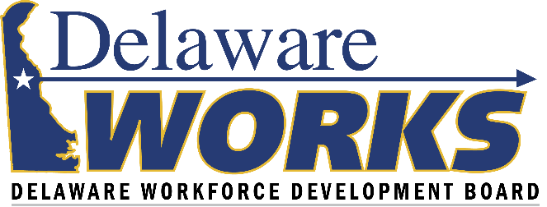

**ITA Programs Removal Form**

Send completed form to: DWDB_ETPL@delaware.gov

Provider Name:____________________________________________________________

|  |  |  |
| --- | --- | --- |
| **PROGRAM TITLE**  **(Must be the same as DJL)** | **EXPLANATION FOR REMOVAL** | **EFFECTIVE DATE** |
|  |  |  |
|  |  |  |
|  |  |  |
|  |  |  |
|  |  |  |
|  |  |  |
|  |  |  |
|  |  |  |
|  |  |  |
|  |  |  |
|  |  |  |
|  |  |  |
|  |  |  |
|  |  |  |
|  |  |  |

Authorized Signer: ___________________________ Date: __________________________________

Printed Name of Authorized Signer: _________________________________________________________